Candidate Email Template: Invitation to Virtual Interview
Hi, <Name>.
Thank you again for your interest in a teaching position at <SCHOOL>. We are impressed by your candidacy and are eager to invite you to the next phase in the process, the virtual interview! Below you will find the interview logistics, tips for virtual interviewing, and instructions on using the Zoom video platform.
As you have questions, please do not hesitate to reach out to <contact>.

Logistics
- Interview Date:
- Interview Time:
- Important Notes:
  - The interview will be conducted via the Zoom video platform. You can find instructions on using the Zoom platform below. The specific link will be sent via a separate calendar invite.
  - Join the video call using both video and audio functions. It is important that we can hear and see you clearly.
  - If you would like to join the meeting early, that should be fine. However, please do not join earlier than 5 minutes before your scheduled interview time.
Best Practices in Virtual Interviewing
- Test your Technology
Today, test your technology to ensure you’re set up for success. Check your internet connectivity, and confirm your camera and microphone are working. If you have trouble logging in, you may need to download the app on your phone (it’s free). If you have trouble accessing the Zoom line, contact me as soon as possible.
- Set the Scene and Minimize Distractions
While testing your technology, determine where you will take your interview. Find a room with optimal lighting, preferably near a window, or a blank wall to guarantee you are the focus of the conversation, not your background. Once you choose your ideal location, eliminate all distractions. Turn off the TV, silence your cell phone, and close any nearby windows to muffle neighborhood traffic.

- Dress the Part
While many of us have spent most of our days in leggings and jeans, we encourage you to dress as you would for an in-person interview. There are personal benefits, as well: Studies show that people feel “most authoritative, trustworthy, and competent when wearing formal business attire.”
- Be Comfortable and Be Yourself
This format can be new for you, but don’t worry, it is also new for some of us, too. Our ultimate goal is to get to know you, share more about our school, and assess whether you would be a great fit for our school community. We are in this together!

Zoom Information and Instructions
You can find the specific Zoom information in the calendar invitation. If you have not received the information, or you have trouble accessing the video, please reach out to me as soon as possible.
How can I access the virtual meeting?
- We will send you an invitation by email with a link to the zoom meeting. You can click the link or copy and paste the address in your browser (Chrome, Explorer…).
- When Zoom is launching the application, click “Open Zoom”. You may be asked to download the app. Please do so and then Accept and join as a Participant. You will be asked to list your first and last name.
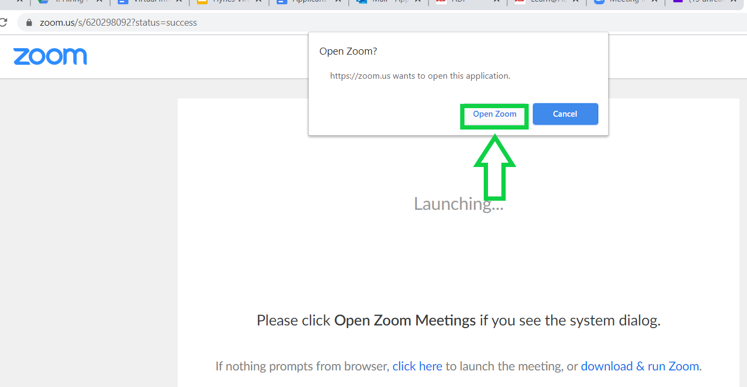
- When you are ready, join with computer audio, if possible. If your speakers do not work, or you have a more reliable phone connection, you can use your phone to dial-in.
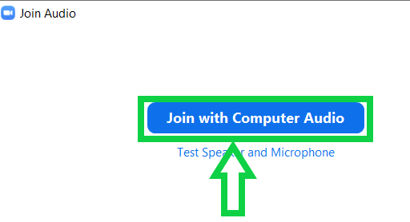

- Check that your camera and microphone are enabled.
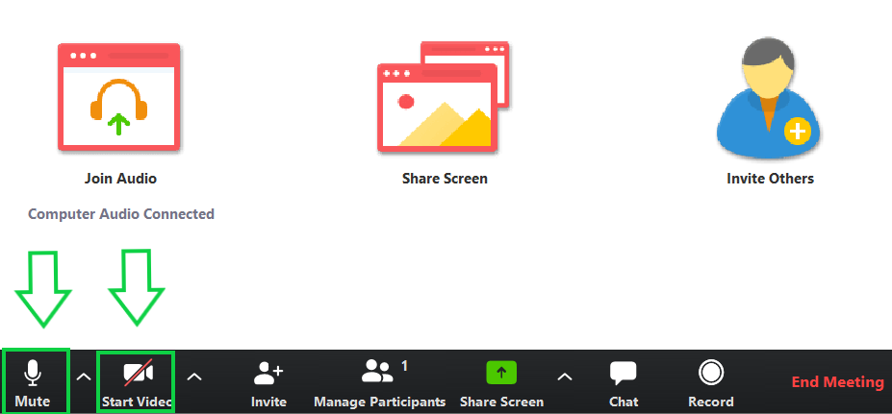

How can I learn more about Zoom?
If you are not familiar with Zoom, watch these useful videos
- Joining a Zoom meeting (1:09): https://www.youtube.com/embed/hIkCmbvAHQQ?rel=0&autoplay=1&cc_load_policy=1
- Configuring Audio & Video (1:42) https://www.youtube.com/embed/-s76QHshQnY?rel=0&autoplay=1&cc_load_policy=1
- Sharing a screen (1:11) https://support.zoom.us/hc/en-us/articles/201362153-How-Do-I-Share-My-Screen-

What if I am unable to complete the interview due to interruptions or unforeseen circumstances?
We understand that managing a consistent schedule can be challenging at this point. We will make every attempt to reschedule with you as needed and ask that you reach out to us as early as possible so that we may adjust the interview time.

